**DAILY ASSESSMENT**

|  |  |  |
| --- | --- | --- |
| **DATE** | **19/05/2020** | NAME Yashwanth V |
| **COURSE** | TCSiON | USN **4AL18EC060** |
| **TOPIC** | 1.**Gain Guidance from career Guru**  **2.Write a winning resume and cover letter**  **3.Stay ahead in Group Discussions** | **SEM 4th sem.A sec**  **sections** |
| **Github Repository** | Yashwanth |  |

**FORENOON SESSION DETAILS**

**Image of session**

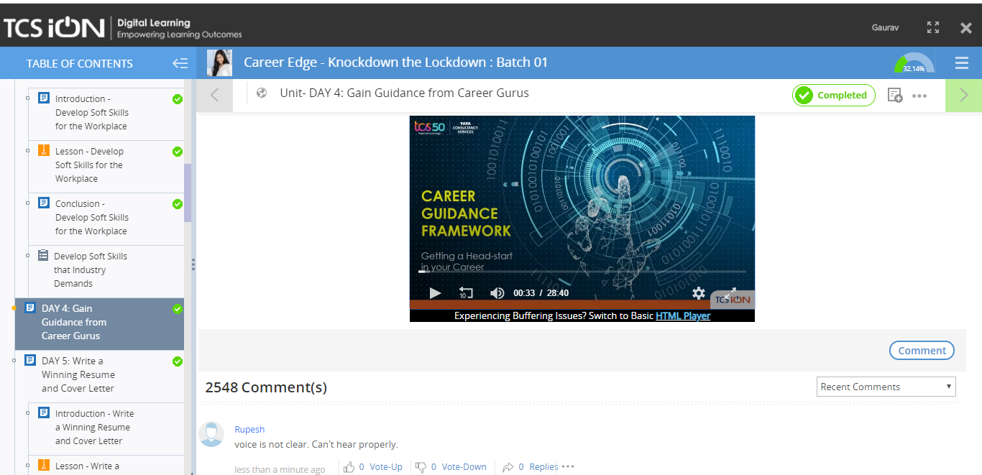

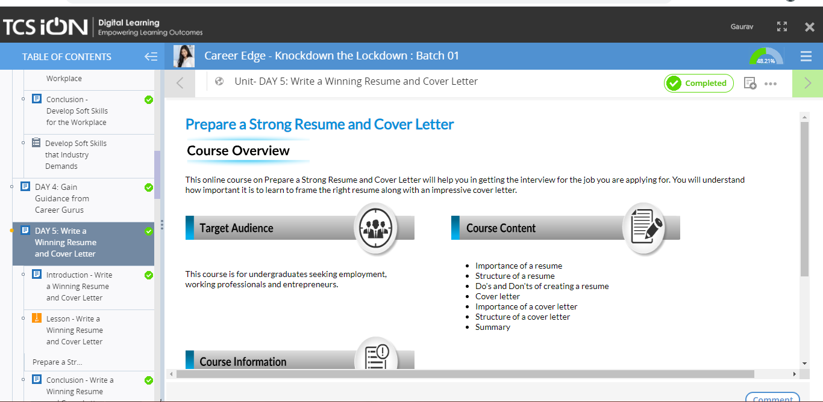

**REPORT : Topic 1 –Gain Guidance from Career Guru**

**Guidance to getting a Head start in Career:**

**Need of headstart:**

* **Intense competition**
* **Talent Acquisition**
* **Employable skill**
* **Changing job roles**
* **Employment outlook**

**6 Key pillars to get Headstart:**

* **Clarity of thoughts**
* **Access and visibility**
* **Early preparation**
* **Acquire relevant skills**
* **Cracking the interview**
* **Compelling resume**

**Topic 2: day 5- Creating a winning resume and cover letter**

**TYPES OF RESUME:**

1. **Chronological resume**
2. **Functional resume**
3. **Combinational resume**

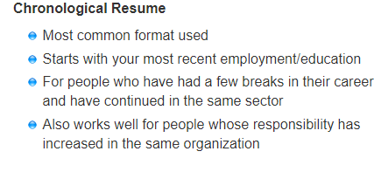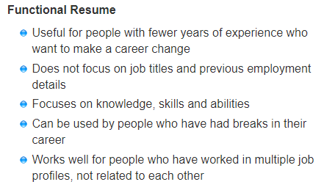

**Structure of Well written Resume:**

1. **Contact details: Name**

**E-mail**

**Mobile number**

1. **Carrier Objectives**
2. **Education qualification**
3. **Technical skills**
4. **Additional qualification/certifications**
5. **Personal details**

**We need to remember some do’s and don’ts while creating a resume:**

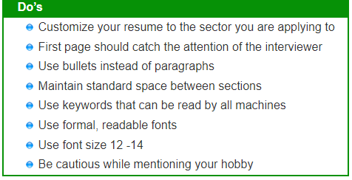

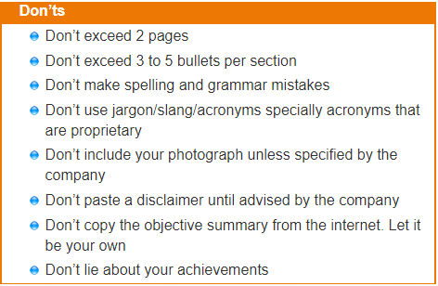**Cover Letter**

**Importance of a cover letter:**

* **A cover letter is read before your resume is read, so it gives an initial impression of you**
* **Each cover letter should be tailor mode to the job you are seeking**
* **The cover letter tells the employer the job role that you are interested in**
* **It tells the employer how qualified you are, for the role**
* **A cover letter expresses the point that your resume might not cover**

**Structure of Cover Letter:**

**Date**

**Your name**

**Your address**

**Phone number**

**Your email id**

**Company official’s name**

**Company name**

**Company Address**

**Pin Code**

**Salutatons**

**Opening paragraph(Contains self introduction and why the company should hire you, that should brief of your experience ,expertise and education)**

**Topic 3:Day 6:Stay Ahead in Group Discussions**

**Group Discussions:**

**\*A Group discussion is a positive exchange of views in a particular topic**

**\*It is a time bond and open to all present in the group**

**\*It is not a competitions or nor an argument where any one person wins**

**\*It is often used as mass grading process**

**DO’s and DON’T’s while in GD:**

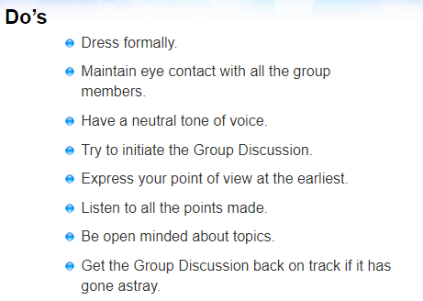

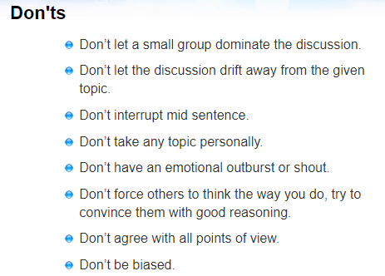

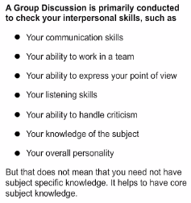

**AFTERNOON SESSION DETAILS**

|  |  |  |  |
| --- | --- | --- | --- |
| **DATE** | **19/05/2020** | **Name** | **Akshaya kumara** |
| **COURSE** | **Python for machine learning by great learning and morsh python** | **USN** |  |
| **Topics** | **1.Introduction to python**  **2.Various IDE used to code python**  **3.Installation of various IDE** | **Sem and section** | **4th sem.A SEC ECE** |
| **Github repository** |  |  |  |

**Images and report of the session:**

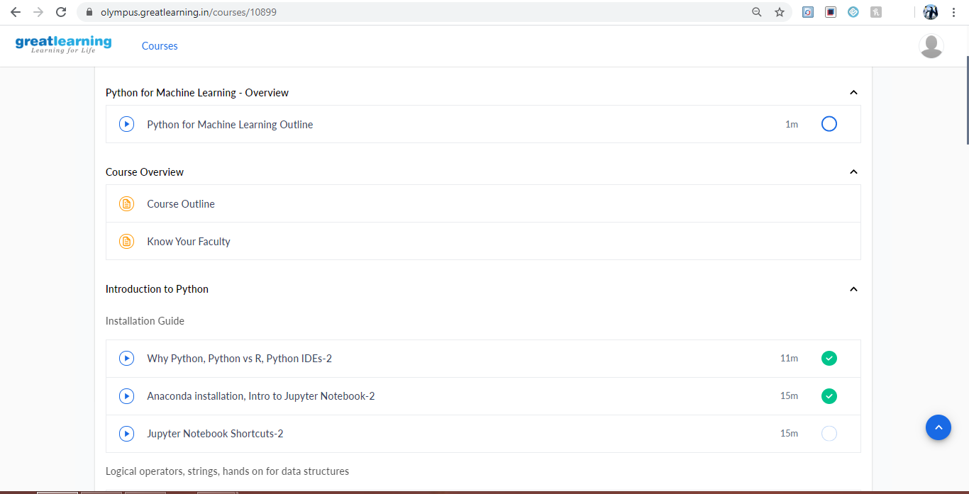

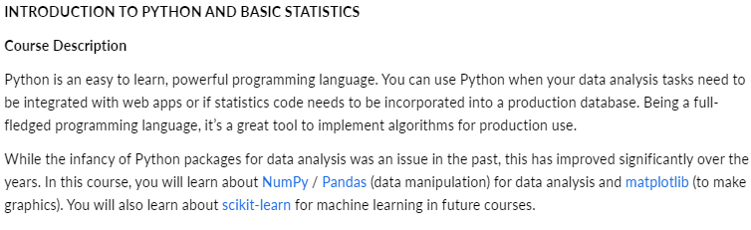

**Various IDE for python : Pycharm, Anaconda, Visual studio, Thonny, Vim etc,**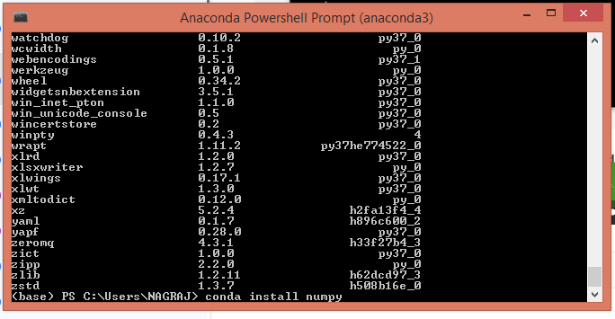

**Anaconda** is quite interesting and powerful ide,which makes use of 2 different ide i.e .**Jupyter notebook, spyder**

**Programing in Jupyter notebook**

